To: Interstate Bridge Replacement administrators
From: Sam Churchill, Hayden Island
E-Mail schurchill@gmail.com
Address: 1503 N. Hayden Is Dr. #869, Portland 97217
Subject: Draft SEIS public comment
Date: Nov. 10, 2024

Dear Administrators:
I am a 76-year-old, low-income person with no car. I live in the Hayden Island RV/Manufactured Home park.

I'm for honesty. We're not getting it from the IBR.

IBR says the I-5 bridge had 143,000 average daily crossings. That was a projection from the CRC in 2005, NOT actual traffic. Covid hit. The 143,000 average daily crossings of I-5 never got close. Instead, the numbers went down dramatically. Everybody knows it.

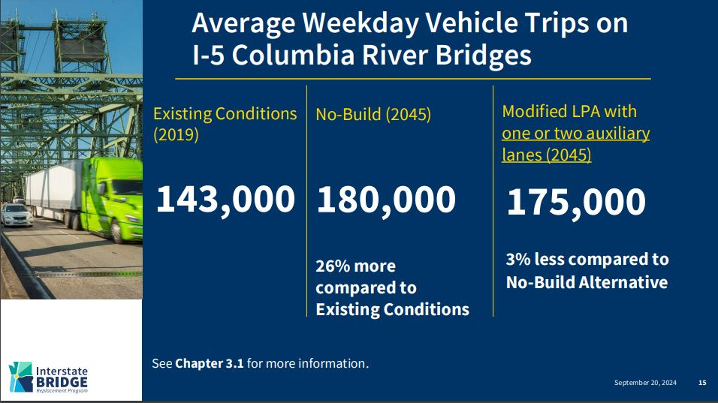

www.interstatebridge.org/media/yvqh2shc/ibr-dseis-press-conf-slides_2024-09-20_remediated.pdf

The ACTUAL average daily crossings of I-5 in 2021 was 130,000, not 143,000.

Traffic peaked at 138,000 in 2019. Then it went down to 120,000 in 2020. The 2023 number is now back up to 133,000. The 2024 figures aren't in yet.

The IBR USED the 143,000 figure in all sorts of (current) presentations. It's a lie and IBR knows it. I eventually gave up trying to correct the IBR.

Washington State has the ACTUAL MEASURED bridge crossings numbers. They're right here (below) for all to see and use. (I-5 is the middle column, I-405 is the right column).

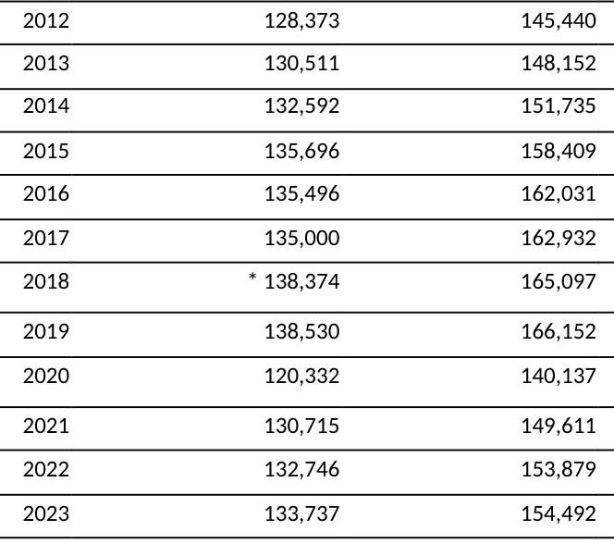
www.rtc.wa.gov/data/traffic/bridges/daily.asp

That's the truth. To their credit, they did NOT fabricate figures in 3.1 of the draft SEIS. Just on all their public PowerPoints.

When IBR says they WON'T sell your personal identity or home address to marketers (and thieves), I just don’t believe them. Why should anyone?

Their track record reflects badly on WS-DOT and O-DOT.

- Sam Churchill
Hayden Island resident

