To: Interstate Bridge Replacement administrators
From: Sam Churchill, Hayden Island
E-Mail schurchill@gmail.com
Address: 1503 N. Hayden Is Dr. #869, Portland 97217
Subject: Draft SEIS public comment
Date: Nov. 10, 2024

Dear Administrators:
I am a 76-year-old, low-income person with no car. I live in the Hayden Island RV/Manufactured Home park.

Properties scheduled for demolition on Hayden Island were NOT clearly identified by the IBR, but by an individual, Jordan Lewis, of Just Crossing Alliance.

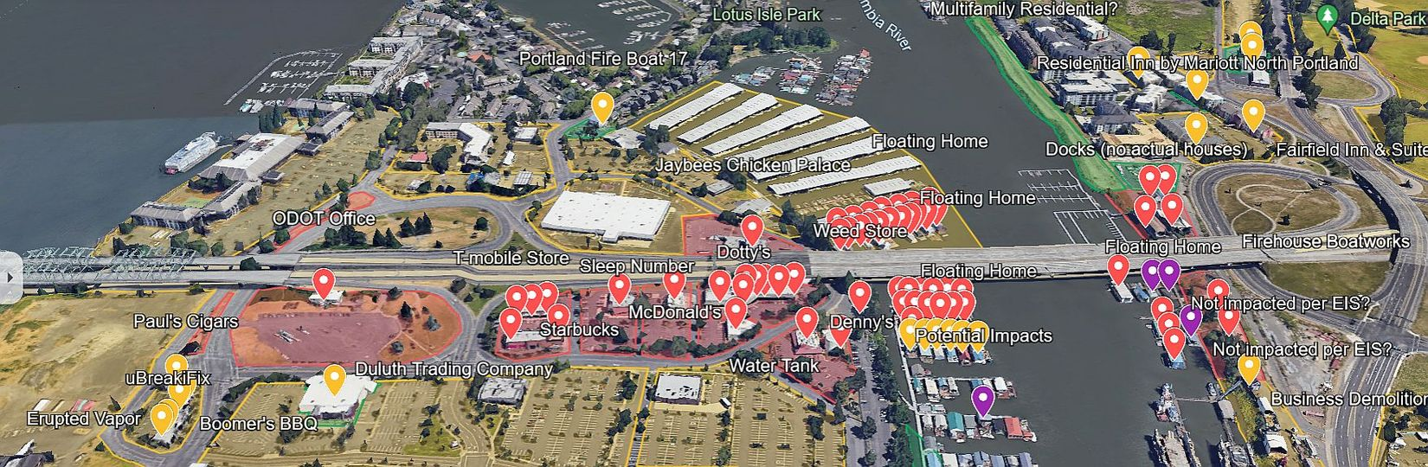

The Interstate Bridge Replacement Program may need to fully or partially acquire a total of 176 parcels, which would displace 43 residential units and 33 businesses across Washington and Oregon. That’s according to the draft supplemental environmental impact statement.

https://www.interstatebridge.org/updates-folder/supplemental-environmental-impact-statement/

The closing of Hayden Island businesses due to the building of the Bridge would include:

1. T-Mobile store
2. Sleep Number Bed
3. Wells Fargo ATM
4. Starbucks
5. Jersey Mike's Subs
6. BJ's Steakhouse
7. Sanford's Restaurant
8. Old Country Kitchen
9. Dede's Deli Triplex
10. Bank of America ATM
11. McDonalds
12. Dotty's
13. Tina's Nail Bar
14. Cardtronics ATM
15. Cafe Dell Toro
16. Anchor Bar
17. Denny's
18. Wild West Emporium
19. 13, JBMI Floating Homes
20. 6, JBMI Floating Homes (in peril)

ALSO IMPERILED ON THE WESTSIDE (North):
21. Original Joe's Barbeque
22. Paul's Cigars
23. Boomer's Barbeque
24. Erupted Vapors
25. uBreakiFix

-- ON EASTSIDE OF BRIDGE
26. Eighteen, boat/moored homes
27. Jaybees Chicken Palace

Where is their compensation coming from? The Trump administration? We could use better assurance.

This doesn't BEGIN to count the REAL impact for Hayden Islanders:

- Where can you move if you lose your floating home or business?
- A toll KILLS the Hayden Island Mall.
- It’s harder to get on and off the island with the IBR plan.
- You can’t get on I-5 directly going south.
- Without a grocery store or hospital, trips to Vancouver are a daily necessity for many.
- The elevator won't work. Hasn't worked in 3 years at Union Station.
- I can barely bike over the current bridge.

Hayden Island residents were left out in the cold. It appears we don’t matter.

- Sam Churchill, Hayden Island resident

